Hinf vs PID

Flexibility is one of the biggest challenges in spacecraft control which comes from large solar panels, antennas, and the sloshing effects in tanks. This issue can also bring parameter uncertainties.

For example, the Spacebus 4000 dealt with flexible modes that were badly damped and had uncertain frequencies at +- 30%. Apparently, the conventional way is to design some filters with carefully tunes parameters together with a PID controller to attenuate its resonance.

Hinf controller showed improved stability margins, stronger robustness, better dynamic performance, and less fuel consumption than the PID controller. Apparently, the entire design process is engineer-friendly – “Half a day’s training session would allow any engineer to design the controller”.

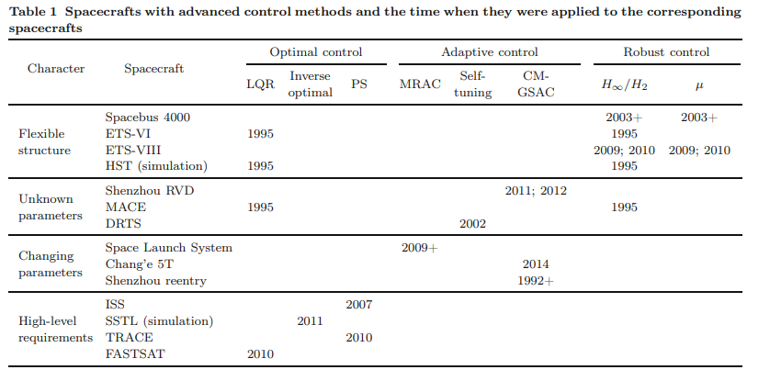Hubble Space Telescope dealt with thermally induced deformations of the solar arrays due to the day-night changes which caused large perturbations in the pointing control system. The PID controller was unable to deal with these perturbations. Multiple modern control strategies were proposed to test this issue. Linear quadratic Gaussian method as well as Hinf were a few of the strategies that seemed to improve the performance.

Optimal control depends highly on the plant models and apparently is performs well in satellite reorientation missions and spacecrafts with high-level requirements.

Robust control is quite useful for flexible structures.

Adaptive control proves to be useful with identifying slowly time-varying parameters that change over a large range. Apparently they perform well for reentry of spacecrafts.

Paper looked at using advanced control methods instead of using the standard PID controller.